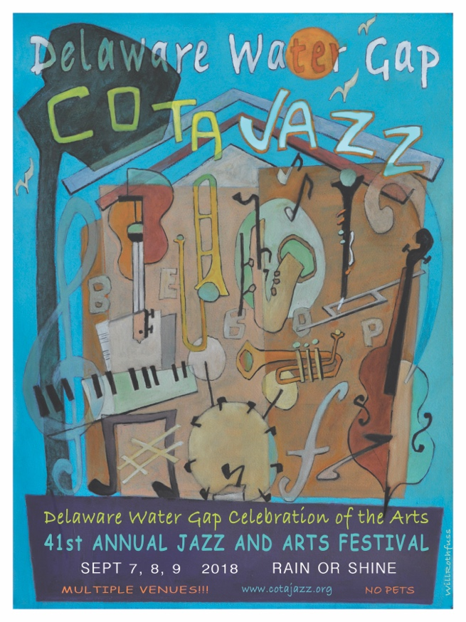

# 2018 DWG CELEBRATION OF THE ARTS MUSIC THEME SHOW

Dear Artisan,

The Delaware Water Gap Celebration of the Arts (COTA) invites you to participate in this year’s art competition. The art show has a musical theme. The competition is open to visual artists in all media, and the individual artist may interpret the subject of the musical theme in any manner.

The artwork will be displayed in the Hall at the Historic Castle Inn in Delaware Water Gap, Pennsylvania during the weekend of the jazz festival. An opening reception will be held at the Hall at the Historic Castle Inn on Friday, September 7, 2018 from 6:00 - 8:00 p.m.

**IMPORTANT** This year we have very limited wall space to display the artwork. This will be a curated show. Please understand that all works may not be able to be displayed downstairs. We are working to provide overflow space upstairs but those works will not be viewable without the $10 entry fee into COToA, the friday night musical performances.

***Jurors: TBD***

***SCHEDULE:***

**Delivery** Artwork must be delivered to the Hall at the Historic Castle Inn, Delaware Water Gap, PA on Wednesday, September 5, 2018 between 4:00 - 6:00 p.m.

**Reception** Friday, September 7, 2017 from **5:00-7:00 p.m.** at the Hall of the Historic Castle Inn, Delaware Water Gap, PA

**Pick-up** **COTA will not be responsible for unclaimed works. WORKS MUST BE PICKED UP BETWEEN 9 AM AND 1 PM ON MONDAY, SEPTEMBER 10TH.**

***REGULATIONS:***

1. **There is a $10.00 entry fee for each piece submitted**. Pre-registration is suggested. **Please fill out the submission form and return it** with your check, payable to Celebration of the Arts (C.O.T.A.), c/o Ian Carrig PO BOX 571 DWG, PA. The submission form can be found on line at [www.cotajazz.org](http://www.cotajazz.org) under the About COTA tab (see Art Show).

1. Artwork must be exhibition ready, appropriately matted and framed.
2. There will not be a size limitation, but **PLEASE REALIZE THAT WE HAVE SPACE LIMITATIONS AND BE REASONABLE!** We reserve the right to refuse an entry because of size/space limitations.
3. Sculpture must be able to fit through a standard door. If a sculpture or craft requires a pedestal, the artist must provide it at delivery of work.
4. Due to space limitations, a maximum of **TWO** works per artist may be submitted.
5. Works will be available for sale. COTA requires a 20% commission on any work sold during the festival.
6. All work must be priced and include the name, address, telephone number and email address of the artist on the back of each entry. If you do not wish to sell, print NFS as the price.
7. Your artwork will be handled with care and security will be provided, but the artist is responsible for insuring their work during the exhibition.
8. The registration and artist’s release forms must be filled out and signed.
9. Works must be delivered to the Hall at the Historic Castle Inn, Delaware Water Gap, PA, on **Wednesday**, **September 5, 2018 between 4:00 pm - 6:00 p.m.**
10. **COTA will not be responsible for unclaimed works. Works must be picked up between 9 AM and 1 PM on Monday, September 10th**.
11. **FOR FURTHER INFORMATION CONTACT (Call or Text) IAN CARRIG at (832) 472-5005 or EMAIL ICARRIG@GMAIL.COM**

MCj04110490000[1] **CELEBRATION OF THE ARTS** MCj01991000000[1]

**MUSICAL MOTIF SHOW REGISTRATION**

Artist’s Name:

Address:

_________________________________________________________

Telephone: Email:

MEDIA & SIZE:

TITLE:

PRICE: ______________

As an exhibitor in the Musical Motif show at the 2018 Celebration of the Arts, I assume full responsibility for my work and display.

Signed:

____________________________________________________________

$10.00 check (per piece) enclosed [ ] made payable to C.O.T.A

**Please return this completed registration form with your check to:**

C.O.T.A.

c/o Ian Carrig

PO BOX 571

DWG, PA 18327